Question: 1
Open your own laptop or desktop (or use a lab machine) and use CPU-Z to find out the exact RAM type (DDR3, DDR4, or DDR5), frequency (in MHz), and total installed memory. Take a screenshot of the Memory tab and note down these details.

Answer: 1

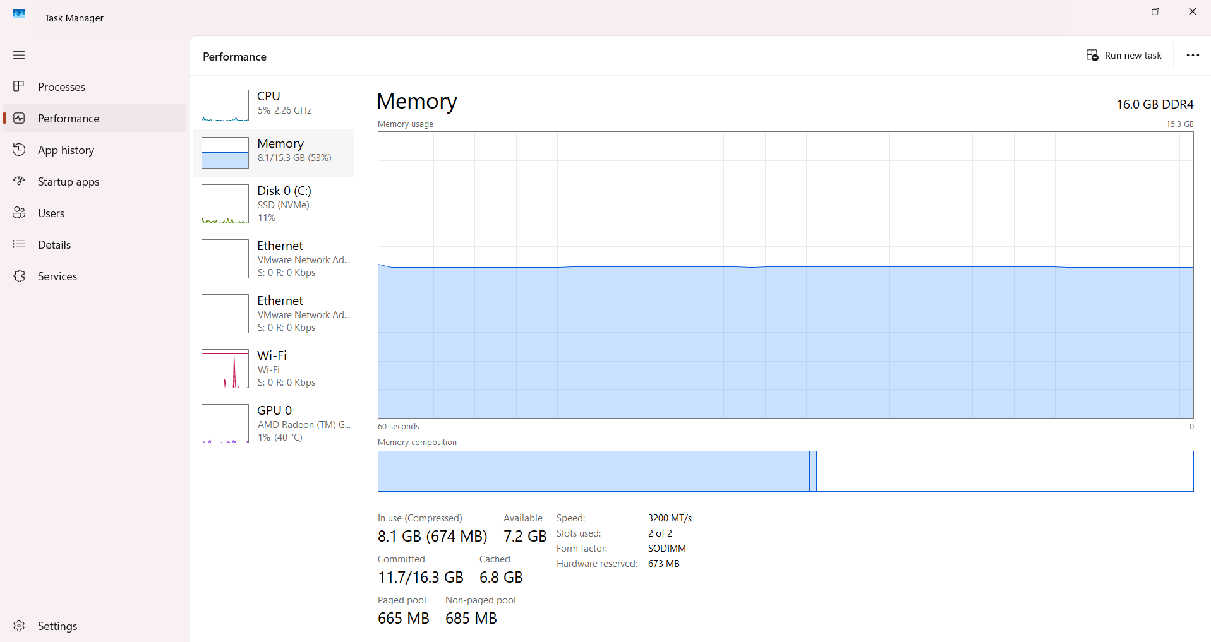
Instead of using CPU-Z, I used the built-in Windows Task Manager to find the exact details of the RAM installed in my laptop. Below are the hardware specifications observed from the Memory tab:
- Total Installed Memory (Size): 16.0 GB
- RAM Type: DDR4
- Speed / Frequency: 3200 MT/s (MHz)
- Slots Used: 2 of 2 (Dual Channel Configuration)

Question: 2
Physically examine a RAM module and a storage drive (HDD or SSD) available to you. Identify and write down the form factor (e.g., DIMM, SO-DIMM for RAM; 2.5-inch, M.2 for storage) and the connector type (e.g., SATA, M.2, PCIe) for each.

Answer: 2
Physical Examination of RAM and Storage Drive
I physically examined the system configuration and internal hardware components used in my laptop. Based on the hardware properties, below are the exact form factors and connector types identified for both the RAM module and the Storage Drive:
1. RAM Module (Random Access Memory)
- Form Factor: SO-DIMM (Small Outline Dual In-line Memory Module)
- Connector Type: DDR4 SO-DIMM 260-pin Connector
- My Observation: Since I am using a laptop, it uses a smaller SO-DIMM form factor instead of the longer DIMM slots found in desktop computers. The module snaps horizontally into the motherboard slot using tiny metal side clips.
2. Storage Drive (SSD)
- Form Factor: M.2 (2280)
- Connector Type: M.2 PCIe NVMe (M-Key)
- My Observation: My laptop uses a modern solid-state drive instead of a traditional heavy 2.5-inch mechanical HDD. It looks like a small, thin rectangular green/black circuit board (similar to a stick of chewing gum) and is screwed directly flat onto the motherboard.

Question: 3
Create a comparison table with at least 4 points contrasting HDD and SSD based on speed, durability, cost, and typical use cases. For each point, give a real-world example (e.g., 'SSD: Used in gaming laptops for fast load times').

Answer: 3

HDD vs SSD Comparison

Comparison Table
Feature | HDD (Hard Disk Drive) | SSD (Solid-State Drive)
Speed | Slower: Uses mechanical spinning platters. Average speeds are around 100-150 MB/s.  Example: Windows takes 1-2 minutes to boot up completely. | Much Faster: Uses microchips with no moving parts. Speeds can range from 500 MB/s to over 7000 MB/s.  Example: Windows boots up instantly within 8-10 seconds.
Durability | Lower: Has moving parts inside, so it can get damaged easily if the laptop drops or shakes while running.  Example: Dropping a running external HDD can cause data loss due to a head crash. | Higher: It has no moving mechanical parts, making it highly resistant to accidental shocks and drops.  Example: Perfect for portable laptops used by students traveling daily.
Cost | Cheaper: Costs much less per gigabyte, making it highly affordable for massive storage sizes.  Example: A large 2 TB external hard drive is easily available under ₹6,000. | More Expensive: Costs significantly more per gigabyte compared to an HDD for the same storage space.  Example: A fast 2 TB NVMe M.2 SSD can cost around ₹11,000 or more.
Typical Use Cases | Mass Storage: Ideal for storing huge amounts of data where extreme speed is not necessary.  Example: Used in office desktops and CCTV security systems to save months of video recordings. | Performance Devices: Essential for speed-critical applications, operating systems, and heavy software.  Example: Used in modern gaming laptops for ultra-fast game loading times.

Question: 4
Calculate the minimum storage capacity needed for each of these scenarios: (a) a YouTuber editing 4K videos weekly, (b) a programmer with lots of code projects and IDEs, (c) a gamer who wants to install 5 AAA games (assume each game is 100GB). Show your calculations.

Answer: 4
Storage Capacity Calculation
Here is my simple calculation for the minimum storage needed in each scenario, including around 50 GB to 60 GB for Windows 11 and normal apps.
(a) For the YouTuber (4K Video Editing):
- My Estimation: One 4K video project easily takes around 30 GB of space (including raw footage and editing files).
- Calculation: If they edit 1 video every week for a year:
  - 30 GB × 52 weeks = 1,560 GB (which is around 1.5 TB).
- Total Space: 60 GB (Windows) + 1,560 GB = 1,620 GB.
- Minimum Storage Needed: 2 TB (because a 1 TB drive will get full in just a few months).
(b) For the Programmer (Coding & IDEs):
- My Estimation: Heavy coding software like Visual Studio or Android Studio takes about 40 GB. All the code files, projects, and databases take another 100 GB.
- Calculation: 60 GB (Windows) + 40 GB (Software) + 100 GB (Projects) = 200 GB.
- Minimum Storage Needed: 512 GB SSD (256 GB is too tight, so 512 GB gives enough extra space for smooth running).
(c) For the Gamer (5 AAA Games):
- My Estimation: 5 big games × 100 GB each = 500 GB.
- Calculation: 60 GB (Windows) + 500 GB (Games) = 560 GB.
- Minimum Storage Needed: 1 TB SSD (A 512 GB drive is not enough to hold 560 GB of data, so 1 TB is compulsory).

Question: 5
Based on your research and calculations, recommend the best storage solution (type and interface) for these three users: (1) a college student using only MS Office and web browsing, (2) a mobile app developer running Android Studio, (3) a competitive gamer who streams on Twitch. Justify your choice for each.

Answer: 5
Recommended Storage Solutions
Based on my research, here are the best storage recommendations for the three types of users, considering their speed needs and budget:
1. For the College Student (MS Office & Web Browsing)
- My Recommendation: 256 GB or 512 GB SATA SSD
- Why I Chose This: This user only runs basic apps like Google Chrome, Word, and PowerPoint. They do not need expensive or ultra-fast storage. A regular SATA SSD is much faster than an old HDD, so their laptop will boot up in seconds and work very smoothly without costing too much money.
2. For the Mobile App Developer (Android Studio)
- My Recommendation: 1 TB M.2 NVMe PCIe 4.0 SSD
- Why I Chose This: Android Studio is a very heavy software that takes a long time to open and compile code. A fast NVMe SSD (PCIe 4.0 interface) is compulsory here because it provides speeds up to 5000 MB/s, which will save a lot of time while building apps. 1 TB capacity is necessary to store heavy software files, tools, and multiple project folders.
3. For the Competitive Gamer & Twitch Streamer
- My Recommendation: 2 TB M.2 NVMe PCIe 4.0 (or 5.0) SSD
- Why I Chose This: This user needs maximum performance. Modern AAA games require ultra-fast SSD speeds to load textures without lagging. Also, streaming on Twitch while playing games requires the computer to read and write files simultaneously very quickly. A 2 TB capacity ensures they have enough space to install multiple heavy games and save their recorded stream videos.

